**Aspen Terminology**

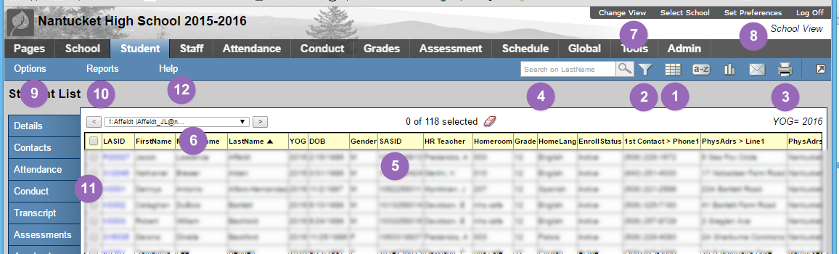

1. Field Set Menu – changes the kind of info displayed (Columns)
2. Filter Menu – changes the number of pages of data displayed (Rows)
3. Print and Export – print to paper or save to computer
4. Search Box – Searches the currently sorted column
5. Column Headers – Sorts columns
6. Change page of Records – display the next batch of records
7. Change View – toggle between District, School, Staff, and Spec. Ed.
8. Change Preferences – change password, number of records per screen
9. Do an Action – Search, consolidate records, Add, and Delete
10. Display a report – Display information and preformatted forms for printing, mail labels, report cards, class lists
11. Student’s detailed info – where all the details live.
12. Aspen Help